**Description:**

This task involves understanding the basic data types in Python such as lists, dictionaries, and sets.

**Dict:**

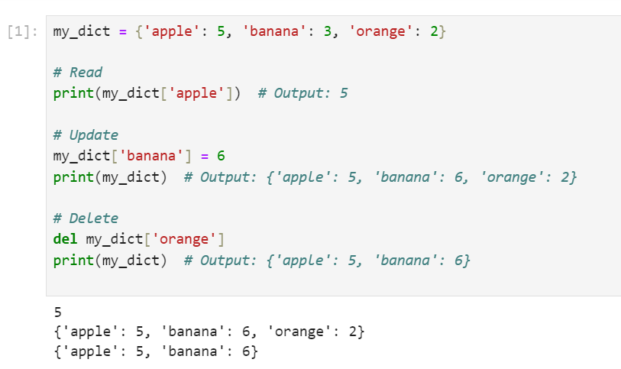

**List:**

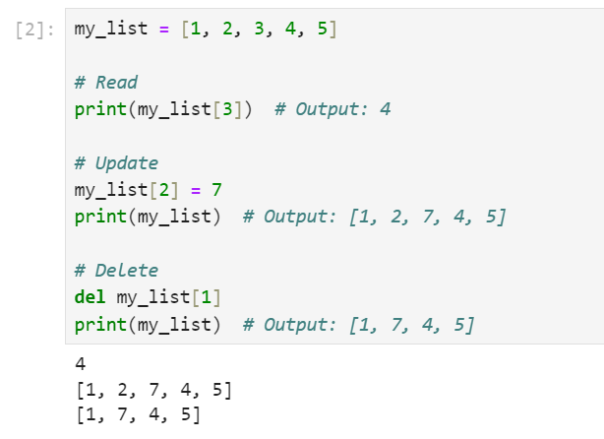

**Set:**

